Case 3: Portfolio Sorting

**Step 0: Organize and Merge Data (RM)**

We have three datasets, one is the Market dataset with 5025 rows, one is the Port data with 5025 observations, one is the Security Id dataset with 6415 rows, including one header and 6414 observations. It has 4 columns, which are “secid”, “permno”, “Ticker” and “Name”.

**Step 1: Drop Firms (Questions)**

We have dropped 3 firms in the Security Id dataset, and the total number of firms in our sample after that is 6411. The starting data is 1990 January 4th, the ending data is 2015 December 31th.

**Step 2: Individual Stock Returns**

**Step 2.1 Numerical Moments (TAB)**

We created a table with the quantile (5, 25, 50, 75, 95) of the time-series mean, standard deviation, skewness, kurtosis, minimum, maximum, AR (1) and annualized sharpe ratio. Also, we include IBM in an additional column.

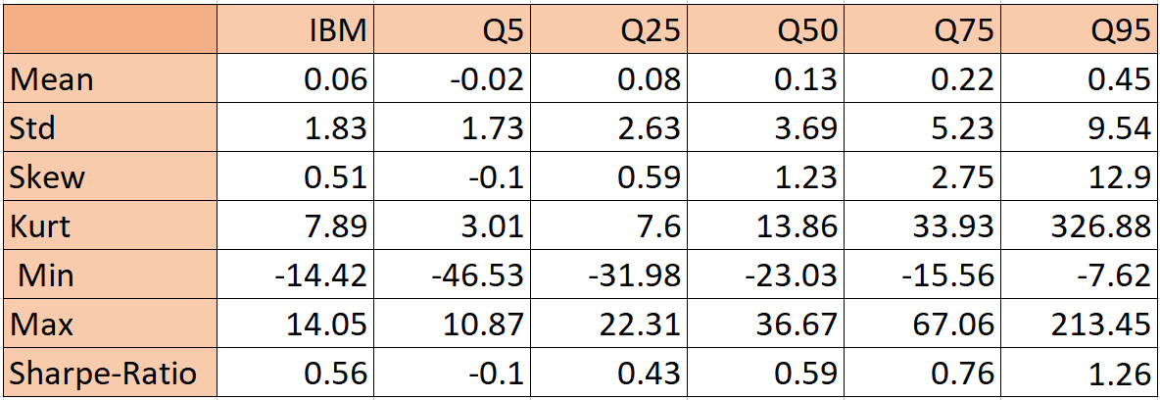

From the above table, we can find that the Sharpe-Ratio of IBM is around the median of the overall market Sharpe-Ratio.

**Step 2.2 Identify the Firms (TAB)**

We created a table that summarize the Sharpe ratios when it is at the min, 50, max quantile. This table also includes the sample length, the starting date and the ending date.

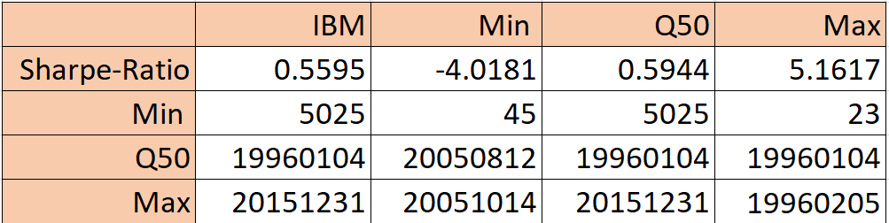

From the above table, we can find that the Sharpe ratios of IBM is around the median number of the overall market Sharpe-Ratio. Hence, we can tell that the risk of IBM stock is on average.

**Step 2.3 Normality Test (HT)**

For the Jarque-Bera test for the disturbances term:

H0: The test is that the data is normally distributed.

H1: The data does not come from a normal distribution.

Decision Rules: Reject if p-value is lower than 5%

Conclusion: After running the codes in R, we found the p - value <2.2e-16, which is obviously lower than 5%. In that case, we decided to reject the hypothesis, which means the data does not come from a normal distribution.

For the lilliefors test for the disturbances term:

H0: The data is normally distributed

H1: The data does not come from a normal distribution

Decision Rules: Reject if p-value is lower than 5%

Conclusion: After running the codes in R, we found the p - value <2.2e-16, which is obviously lower than 5%. In that case, we decided to reject the hypothesis, which means the data does not come from a normal distribution.

**Step 3: Beta Estimation**

**Step 3.2 OLS Regression Firm By Firm(ESF)**

In this step our goal is to test whether stock with different sensitivities to the market excess return have different average returns. in this step we used one factor model with market excess returns as the only factor in the model.

**estimate equestion:**

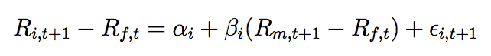

**Result:**

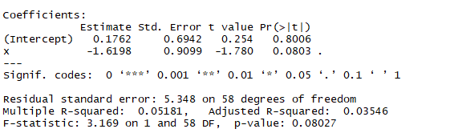

The result when we call the model in R shows the Beta of the regression is negative -1.6198 where we conclude that the stock has a negative direction to the market excess return. Furthermore, in our P-value we see it is very close to zero 0.08027 which mean we reject the null hypothesis where stocks with different sensitivities to the market excess returns have not different average returns.

**Step 4: Portfolio Sorts**

**Step 4.2 Portfolio Returns(TAB+ FIG)**

For each portfolio returns, we compute the time-series average, time-series standard deviation, p-value for the mean and the Sharpe ratio. Create a Barplot for these five time-series averages.

**Result:**

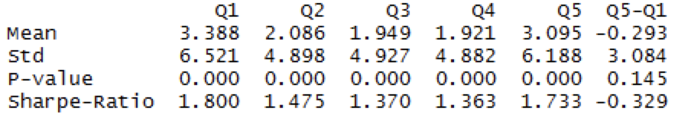

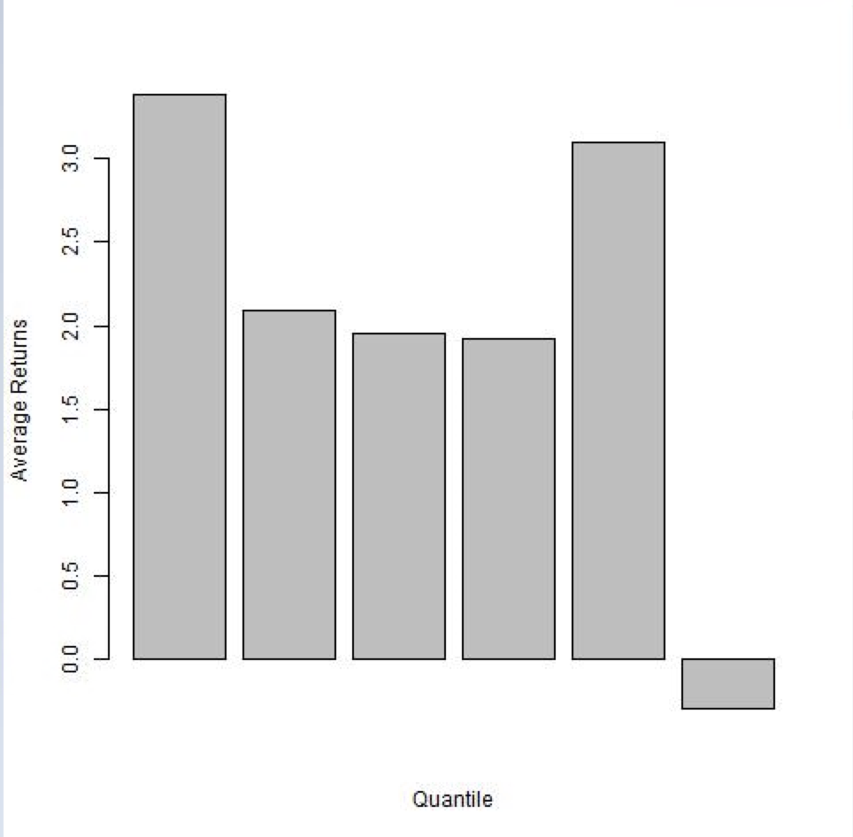

In our figure above, we see the highest mean of the portfolio is Q1 which mean Q1 has yield the most return to investor. However, this result also told us that Q1 has the highest standard deviation in which translate to the risk of the investment. it is logically making sense where higher risk tends to give more return of investment. The sharpe ratio has become the most widely used method for calculating the risk adjusted return. it is used to help the investors understand the return of an investment compared to its risk. in our result, we found Q1 “1.800” has the highest sharpe ratio where is the average return earning is excess of risk free per unit of volatility or total risk. Investors tend to more favorable to the highest sharpe ratio.

**Step 4.3 Return Differential (HT)**

In this step, we create the 5-1 returns between the quintile portfolios with the highest and lowest beta coefficients. According to CAPM, this spread should be significantly positive. Setup a hypothesis to test for this implication.

**Testing:**

We set the null hypothesis and its alternative where:

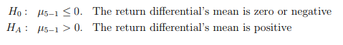

**Decision rule:** reject the null if the return differential’s mean is positive

**Conclusion:** After running the codes in R, we found that the return differential mean is -1.492609 which is less than zero. we fail to reject the null of hypothesis.

**Step 5.1 Estimate the Market Risk Premium month by month (FIG)**

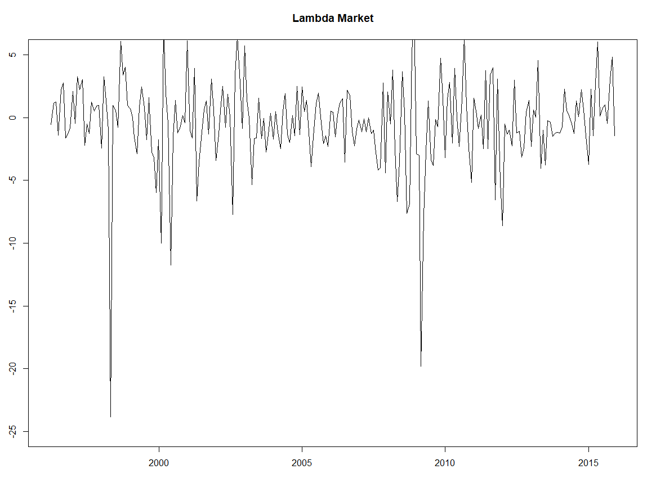

This graph displays how the slopes of the cross-sectional regression change as the months going. The x-axis shows the time scope, which are the months from 1996 to 2015. The y-axis displays the scope of the slopes, from -25 to 5, which obviously are the coefficients of β in our regression model. It can be found that the values consistently fluctuated around 0. The maximum value of slopes is higher than 5, appearing in November 2008, which could be explained by the financial crisis in 2008. The minimum value of slopes is approximately approaching to -25, happening in April 1998.

**Step 5.2 Is the market risk positively priced? (HT)**

We then compute the average price of the market risk . To test whether the market risk is being positively priced, we setup the null and alternative as following:



After running the model in R, we easily find that the test value of the regression model is -1.993227

**Decision Rule:** if the test value of the model is higher than 95% of the monthly index 1.651336, we will reject the null hypothesis and accept the alternative hypothesis, which means the market risk is positively priced.

**Decision:** Since the test value we get above is lower than 95% of the monthly index 1.651336, the null hypothesis can not be rejected. We will choose to accept the null hypothesis. It shows the market risk is not positively priced.

**Step 5.3 Are there other factors? (HT)**

We want to test another CAPM implication that whether the intercept is zero. We again start by computing the average . To test whether the intercept is zero, we setup the null and the alternative as following:



After running the hypothesis test in R, we find the p-value of the regression model is 0.04739.

**Decision Rule:** if the p-value of the model is lower than 5%, we will reject the null hypothesis and accept the alternative hypothesis, which means other factors matter the market.

**Decision:** Since the p-value we get above is lower than 5%, the null hypothesis could be rejected. We will accept the alternative hypothesis, which means CAPM model can not be used here and other factors matter.

**Step 6: Volatility Factor Innovation**

**Step 7.1 OLS regression firm by firm**

In this step, our goal is to test whether stocks with different sensitivities to volatility innovations (controlled for their exposures to the market excess returns) have different average returns. This is a two-factor model with the market excess returns as the first factor and the volatility innovations as the second factor.

**Estimate equestion:**



**Result:**

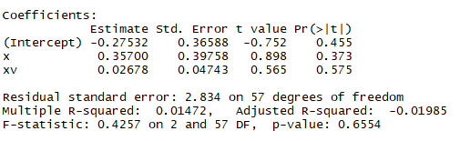

The result when we call the model in R shows the Beta where is our first factor of the regression is negative -1.78858 where we conclude that the stock has a negative direction to the market excess return. our second factor of the regression is -0.06807 which is very close to zero. this explain us that the portfolio has no correlation with the volatility of the index. On top of that, in our P-value is 0.2158 which mean we fails to reject the null hypothesis with different sensitivities to volatility innovations have different average return. which give us our predict that the stocks have a opposite direction to the overall market excess return.

**Step 8: Portfolio Sorts**

**Step 8.2 Portfolio Returns(TAB+ FIG)**

For each portfolio returns, we compute the time-series average, time-series standard deviation, p-value for the mean and the Sharpe ratio. Create a Barplot for these five time-series averages.

**Result:**

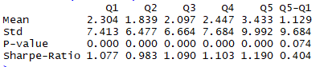

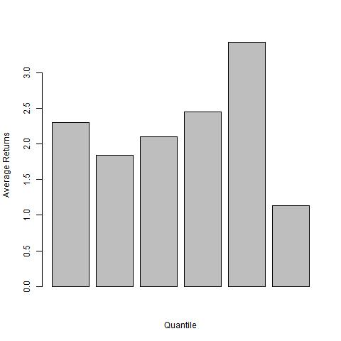

In our figure above, we see the highest mean of the portfolio is Q5 which mean Q5 has yield the most return to investor. However, this result also told us that Q5 has the highest standard deviation in which translate to the risk of the investment. It is logically making sense where higher risk tend to give more return to investment. the sharpe ratio has become the most widely used method for calculating the risk adjusted return. It is used to help the investors understand the return of an investment compared to its risk. in our result, we see Q5 “1.190” has the highest sharpe ratio where is the average return earning is excess of risk free per unit of volatility or total risk. Investors tend to more favorable to the highest sharpe ratio.

**Step 8.3 Return Differentials (HT)**

In this step, we create the 5-1 returns between the quintile portfolios with the highest and lowest Beta coefficients. According to APT with volatility factor, this spread should be significantly negative. Setup a hypothesis to test for this implication.

**Testing:**

We set the null hypothesis and its alternative where:

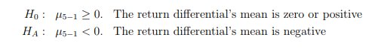

**Decision rule:** reject the null if the return differential’s mean is negative

**Conclusion:** After running the codes in R, we found that the return differential mean is -1.651335 which is negative. we rejected the null of hypothesis.

**Step 9: Risk Premium**

**Step 9.1 Estimate the risk premium month by month(FIG)**

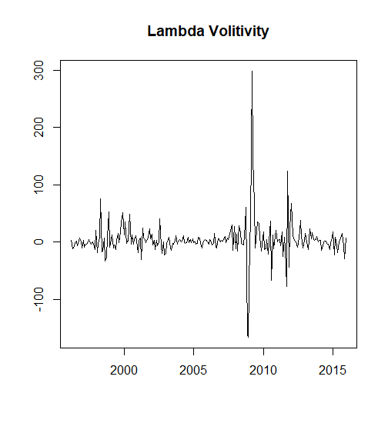

This graph displays how the slopes of the cross-sectional regression change as the months going. The x-axis shows the time scope, which are the months from 1995 to 2015. The y-axis displays the scope of the slopes of market risk premium, from -150 to 300. In this step we used volatility as another factor in our regression. In our figure above the values consistently fluctuated around 0. the peak level is at 300, which occurs in 2008. As recall, it was the post-crisis in the subprime mortgage market in the United States. This explains us that the stock option’s price will change for a given change in the implied volatility. In this period, we can assumed that the option value is very sensitive to a small change in volatility. The lowest level of of slopes is approximately approaching to -150, happening in pre-crisis in the subprime mortgage market in the United States. at this low level, we assume that change in volatility will not have much effect on the stock option.

**Step 9.2 Is the volatility risk negatively priced? (HT)**

We then compute the average price of the volatility risk . To test whether the volatility risk is being negatively priced, we setup the null and the alternative as the following:



After running the model in R, we easily find that the test value of the regression model is 1.76578

**Decision Rule:** if the test value of the model is higher than 95% of the monthly index 1.651336, we will reject the null hypothesis and accept the alternative hypothesis, which means the volatility risk is positively priced.

**Decision:** Since the test value we get above is lower higher than 1.651336, the null hypothesis can be rejected. We will choose to not accept the null hypothesis. It shows the market risk is negatively priced.

**Step 9.3 Are there other factors? (HT)**

We want to test the APT implication that whether the intercept is zero. We again start by computing the average the . To test whether the intercept is zero, we setup the null and the alternative as the following:

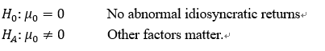

After running the hypothesis test in R, we find the p-value of the regression model is 9.953095e-12.

Decision Rule: if the p-value of the model is lower than 5%, we will reject the null hypothesis and accept the alternative hypothesis, which means other factors matter the market.

Decision: Since the p-value we get above is lower than 5%, the null hypothesis could be rejected. We will accept the alternative hypothesis, which means other factors matter.

**exam Q&A:**

**YW:**

**HS:**

**any oustanding question ?**

**17**

**> summary(mean_sk)**

**Min. 1st Qu. Median Mean 3rd Qu.**

**-0.15589 -0.11547 -0.08944 -0.09515 -0.07456**

**Max.**

**-0.04969**

**10?**

|  |  |  |  |
| --- | --- | --- | --- |
| **Mean** | **Standard Deviation** | **Skewness** | **Kurtosis** |
| **%** | **%** |  |  |

**170.61 76.18 1.4206 2.1182**

**18**

|  |  |  |  |
| --- | --- | --- | --- |
| **Q1** | **Q2** | **Q3** | **Q4** |
| **%** | **%** | **%** | **%** |

**1.431882 1.196140 1.303577 1.045719**

**everyone is good ?**

**Q11?**

**ARMA GARCH model** [**Exam2_Part1.csv**](https://blackboard.syracuse.edu/bbcswebdav/pid-5154860-dt-content-rid-38015857_1/xid-38015857_1)

**Summary statistics for IBM excess return.**

|  |  |  |  |  |
| --- | --- | --- | --- | --- |
| **Mean** | **Standard Deviation** | **Maximum** | **Minimum** | **Correlation\*** |
| **%0.0736874** | **%1.827057** | **%14.069** | **%-14.394** | **-0.043777** |

**\*The correlation between IBM excess returns and VIX2**

**Q17 ?**

**17**

**> summary(mean_sk)**

**Min. 1st Qu. Median Mean 3rd Qu.**

**-0.15589 -0.11547 -0.08944 -0.09515 -0.07456**

**Max.**

**-0.04969**

**STEP 4: Report the 25th Quantile, 50th Quantile, and 75th quantile**

**25 -0.11547**

**50 -0.08944**

**Q19 & Q20 ?**

**cant reject&reject**